**Network Terminologies:**

**1.** **IP Address (Internet Protocol Address)**

* **Description:** A unique string of numbers separated by periods that identifies each computer using the Internet Protocol to communicate over a network.
* **Example:** 192.168.1.1

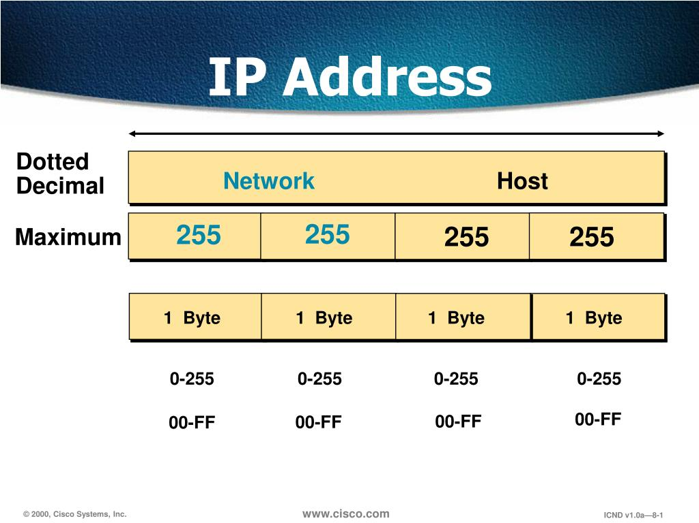

**2. MAC Address (Media Access Control Address)**

* **Description:** A hardware identification number that uniquely identifies each device on a network.
* **Example:** 00:1A:2B:3C:4D:5E

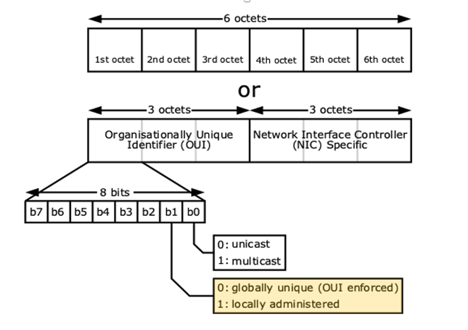

**3. Router**

* **Description:** A device that connects and routes data between multiple networks, directing the data along the most efficient routes.
* **Example:** A device that connects a home network to the Internet.

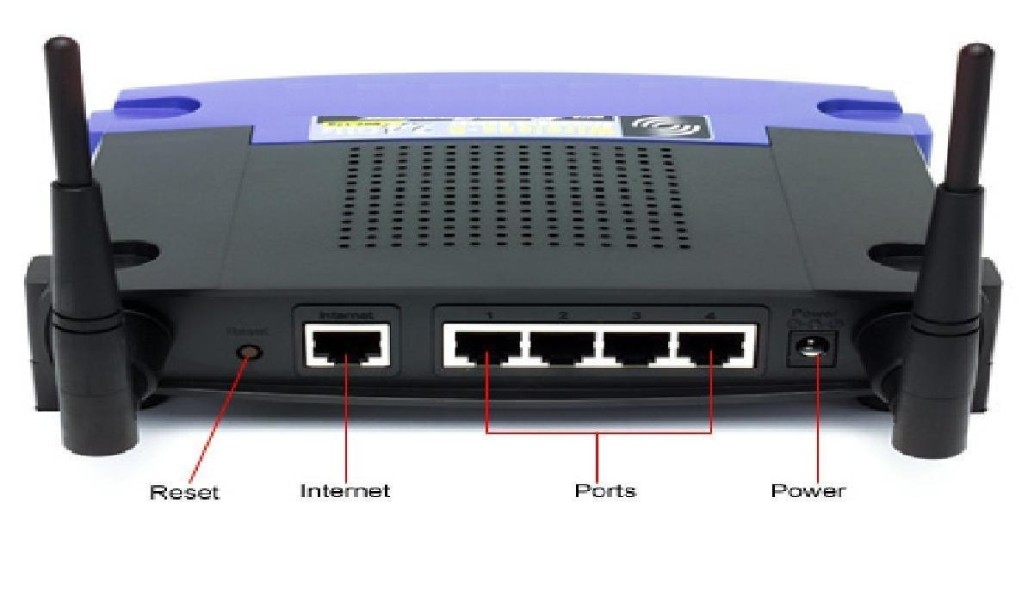

**4. Switch**

* **Description:** A device in a network that filters and forwards packets between LAN segments.
* **Example:** A network switch connecting multiple computers within a local area network (LAN).

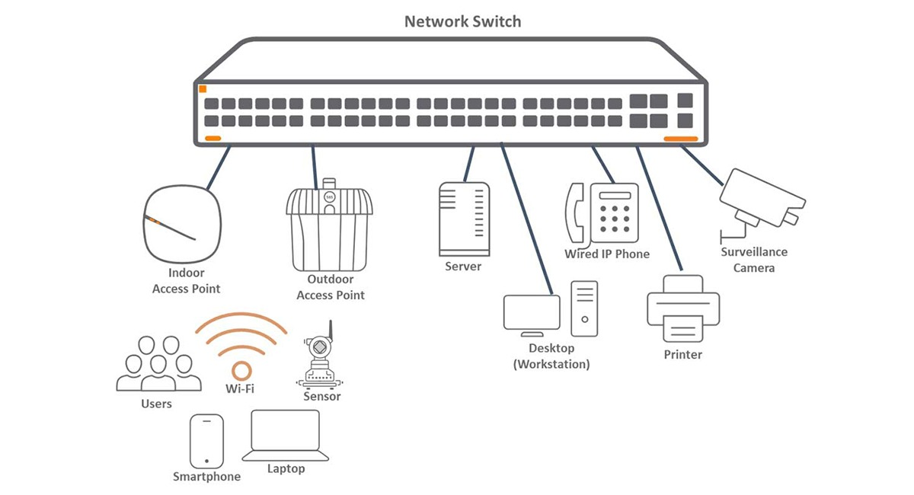

**5. Subnet Mask**

* **Description:** Used in IP addressing to divide a network into subnetworks. It specifies the network's portion of an IP address.
* **Example:** 255.255.255.0

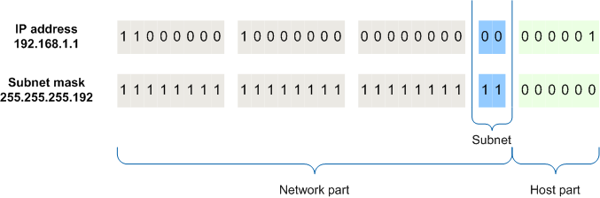

**6. Gateway**

* **Description**: A node that serves as an access point to another network, often used to connect a local network to the Internet.
* **Example:** 192.168.1.1 (often the IP address of a router)

**7. DNS (Domain Name System)**

* **Description:** Translates domain names into IP addresses, allowing users to access websites using human-readable addresses.
* **Example:** Resolving www.example.com to 93.184.216.34

**8. DHCP (Dynamic Host Configuration Protocol)**

* **Description:** A network management protocol used to dynamically assign an IP address to each device on a network.
* **Example:** Automatically assigning IP addresses to devices on a network.

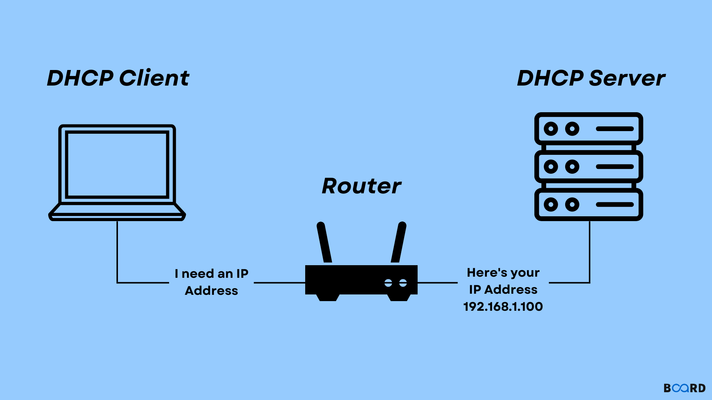

**9. VPN (Virtual Private Network)**

* **Description:** Extends a private network across a public network, enabling users to send and receive data as if their devices were directly connected to the private network.
* **Example:** Connecting to a company’s network from a remote location securely.

**10. Firewall**

* **Description:** A network security device that monitors and controls incoming and outgoing network traffic based on predetermined security rules.
* **Example:** A security system blocking unauthorized access while permitting outward communication.

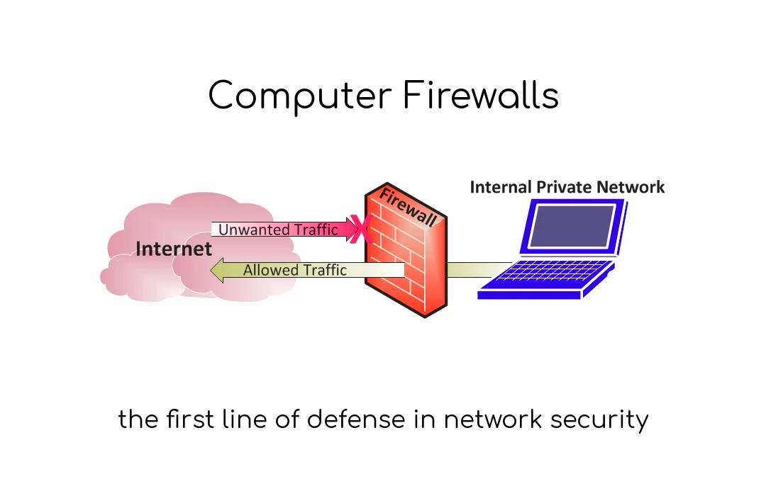

**11. Bandwidth**

* **Description:** The maximum rate of data transfer across a given path.
* **Example:** A 100 Mbps internet connection.

**12. Latency**

* **Description:** The time taken for data to travel from the source to the destination.
* **Example:** 20 milliseconds (ms) delay in data transmission.

**13. Port**

* **Description:** A virtual point where network connections start and end. Ports are used by TCP and UDP protocols for communication.
* **Example:** HTTP typically uses port 80.

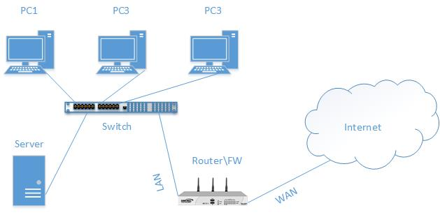

**14. SSID (Service Set Identifier)**

* **Description:** The name of a wireless network.
* **Example:** "HomeNetwork"

**15. NAT (Network Address Translation)**

* **Description:** A method of remapping one IP address space into another by modifying network address information in the IP header of packets while they are in transit.
* **Example:** A router using NAT to allow multiple devices to share a single public IP address.

